Sialolipoma of a minor salivary gland in a dog
A 10-year-old female spayed Golden retriever dog presented for evaluation of a one-year history of progressive panting, inspiratory stridor, and gagging. Oropharyngeal examination revealed a 5 cm x 6 cm soft, pink, nonulcerated, pedunculated mass arising from the region of the right tonsillar fossa. An excisional biopsy of the mass was performed. Histologically the mass was composed of mature adipose tissue with occasional salivary gland elements surrounded by a thin fibrous capsule; consistent with a diagnosis of sialolipoma. The mass was completely excised and no evidence of tumor regrowth was seen on oral examination 6 months post-operatively. Sialolipomas have not previously been reported in animals, and should be considered as a differential diagnosis for oral masses and sialomegaly in dogs.

------------------------------------------------------------------------------------------------------------------

Introduction
Sialolipoma is a rare benign neoplasm composed of mature adipocytes encased in a fibrous capsule with entrapped non-neoplastic salivary gland tissue. Sialolipomas have only been recognized as a distinct entity in people in the last 10 years¹. Since then, more than 35 cases of sialolipoma have been documented in people². To our knowledge, sialolipomas have not been reported in a domestic animal. The purpose of this report is to describe the clinical and histologic findings of a sialolipoma in a dog.
Case Report
A 10-year-old female spayed Golden retriever was referred for suspected laryngeal paralysis. The dog presented to its regular veterinarian with a one year history of progressive panting, inspiratory stridor, intermittent stertor, and gagging while eating. The stertor was worse while sleeping and during exercise or excitement. Hematology, serum biochemistry, serum total thyroxine and thyroid-stimulating hormone tests performed prior to referral were normal. There was no history of significant previous health problems, and the dog was not on any current medications.

On physical examination, the dog was bright, alert, and panting with intermittent inspiratory stridor. A soft expiratory stertor was appreciated on laryngeal auscultation. Thoracic and cardiac auscultation was unremarkable. No abnormalities were detected on laryngeal and tracheal palpation. The remainder of the examination was within normal limits.

Cervical radiographs revealed a 3.5 cm x 4.5 cm soft-tissue opacity in the pharynx, which displaced the nasopharynx dorsally and extended caudally to the epiglottis (Figure 1). There was moderate calcification of the laryngeal cartilages. Thoracic radiographs showed no evidence of aspiration pneumonia, megaesophagus, or pulmonary masses.

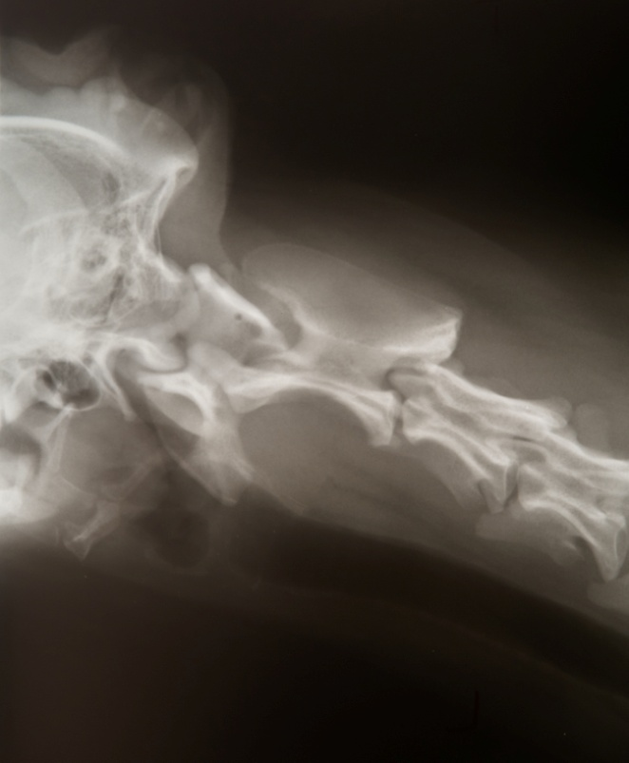
Figure 1. Lateral radiograph of the pharynx of a 10-year-old Golden retriever diagnosed with a sialolipoma of the minor salivary glands. The soft tissue mass is seen to occupy the majority of the oropharynx and displaces the nasopharynx dorsally.
The dog was premedicated with butorphanolª (0.2 mg/kg IV) and induced with propofol^{b} (4 mg/kg IV) for oral examination. A 5 cm x 6 cm soft, pink, nonulcerated, pedunculated mass was found originating at the caudal margin of the right tonsillar fossa. The pedicle was approximately 1.5 cm x 0.5 cm in diameter. The bulk of the mass was lying within the rima glottidis causing a 90% obstruction, and was easily displaced back into the oropharynx with a tongue depressor. The arytenoid cartilages were fully abducted during the oral examination, and laryngeal function was considered to be normal.

Fine needle aspiration of the mass yielded no cells. Due to the occlusion of the larynx caused by the mass, and the risk of respiratory obstruction during anesthetic recovery, an excisional biopsy was performed. General anesthesia was maintained with isoflurane^{c} in 100% oxygen. An elliptical incision was made in the pharyngeal mucosa at the base of the pedicle, and included the right palatine tonsil. The mass was sharply dissected from the underlying submucosal tissue and removed en bloc. The entire mass was placed in 10% neutral buffered formalin^{d} and submitted for histopathologic examination. The mucosa and submucosa were closed with 4-0 poliglecaprone 25e in a simple continuous pattern. The dog recovered well from surgery with no respiratory compromise, and was discharged two days later with tramadol^{f} (3 mg/kg PO q 8 h) and meloxicam^{g} (0.1 mg/kg PO q 24 h). The inspiratory stridor and expiratory stertor had resolved.

On cut section, the mass appeared soft, white and greasy. Microscopically, the pedunculated polypoid mass was surrounded and well demarcated by a relatively uniform, capsule-like layer of fibrous connective tissue. The free outer surface of the polyp was covered by keratinized stratified squamous epithelium (Figure 2A). The bulk of the polyp consisted of lobules of mature adipose tissue with smaller amounts of salivary tissue scattered throughout (Figure 2B). The salivary tissue was composed of acini, lined by well-differentiated mucous epithelial cells, which occasionally surrounded ducts that often contained small amounts of mucus. The palatine tissue at the base of the polyp contained some tonsillar-like lymphoid tissue and in the deeper submucosa contained some lobules of mucous-type salivary glands. This was consistent with a diagnosis of sialolipoma.
A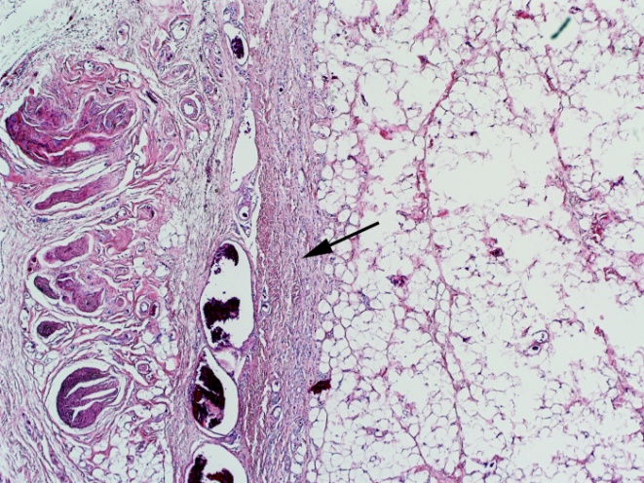
B
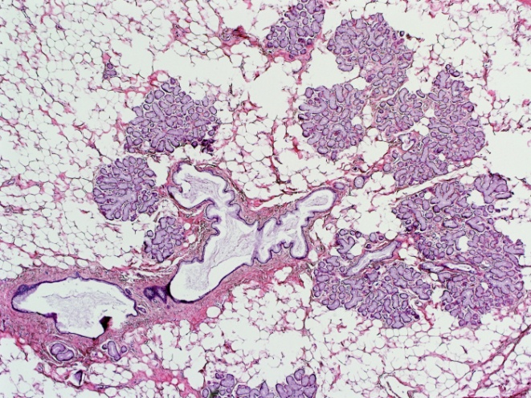
Figure 2. Photomicrographs of a sialolipoma in a dog. A: The sialolipoma is surrounded by a layer of fibrous connective tissue, the outer surface of which is covered by a layer of stratified squamous epithelium. Hematoxylin and eosin stain, original magnification x10. B: Higher magnification showing a cluster of mucous acinar glands adjacent to a duct containing some mucus. Hematoxylin and eosin stain, original magnification x20.

Six months after surgery, oral examination under heavy sedation with dexmedetomidine^{h} (7 mcg/kg IV) and butorphanolª (0.1 mg/kg IV) revealed no visible regrowth at the site of tumor removal. Clinically the dog was doing well, with no further inspiratory stridor or excessive panting.
Discussion
Histologically, sialolipomas are well-circumscribed masses of mature adipocytes with islands of salivary gland parenchyma surrounded by a thin fibrous capsule¹. The adipose tissue may account for 40-90% of the tumor volume^{1,3}. The salivary gland elements comprise acini and ducts, which may be normal or have evidence of acinar atrophy, ductal dilatation, and ductal oncocytic metaplasia^{1,3,4,5}. The epithelial islands may be distributed throughout the tissue or located at the periphery. Immunohistological results have shown that the acini-duct complexes express normal cellular phenotypes and have no proliferative activity¹. Some tumors have lymphoplasmacytic infiltration and discreet areas of fibrosis⁶. The mass in this case report consisted of mature adipose tissue with scattered islands of normal acini and ducts surrounded by a capsule of fibrous tissue, which is consistent with the classification of sialolipoma.

One author has proposed the histogenesis of sialolipomas may be related to a type of salivary gland dysfunction, similar to sialoadenosis, which results in an altered salivary gland structure⁷. A more common histogenetic theory is that it is a simple lipoma that entraps normal salivary gland tissue¹.

Salivary glands in dogs are divided into major and minor salivary glands. The major salivary glands include the parotid, mandibular, sublingual, and zygomatic⁸. The minor salivary glands are distributed throughout the lips, cheeks, tongue, hard palate, soft palate, pharynx and esophagus, and collectively produce what is thought to be a significant amount of mucous secretion⁸.

In people, sialolipomas affect both the major and minor salivary glands in equal proportions. They occur most commonly in middle-aged people, but have also been reported in newborns⁹. They are typically slow-growing, soft, and painless². Growth in children is reported to be more rapid than in adults⁹. Depending on the size and location, they may interfere with mastication, swallowing, and respiration. Similarly in this case, the sialolipoma was in an older patient and presented as a soft and painless mass. It was unknown how long the mass had been present, but the progression of clinical signs over the course of one year suggests that it was slow-growing.
Sialolipomas of the major salivary glands affect males more frequently than females⁵. Approximately 90% of the reported cases in people affect the parotid salivary gland, with the balance affecting the submandibular gland^{3,5,6}. Sialolipomas of the major salivary glands have not been reported in animals, but could be considered as a differential diagnosis for sialomegaly.

Sialolipomas of the minor salivary glands affect men and women equally⁵. The majority of cases involve the hard and soft palates (37.5%); they have also been reported on the lip, tongue, floor of the mouth, retromolar pad, buccal sulcus, and buccal mucosa^{2,6,7,10,11}. On cut section they usually resemble a lipoma, as did the sialolipoma in this report^{1,2}. There have been no reports of malignant transformation or recurrence after marginal excision in people^{1,4,5}. Likewise, no recurrence of the reported sialolipoma was seen 6 months after surgical excision.

Imaging with computed tomography typically reveals a well-demarcated mass with a low-density signal⁶. Magnetic resonance imaging may show a hyperintense mass on the T1-weighted images and isointensity on the T2-weighted images, consistent with subcutaneous fat⁶. Other authors have found a heterogenous signal on the T1- and T2-weighted images^{1,12}. If the sialolipoma in this case had been located in a less life-threatening location, advanced imaging may have increased the index of suspicion for a well-circumscribed benign lipomatous mass. In future cases, advanced imaging and/or incisional biopsy may prove beneficial in the preoperative planning of sialolipomas.

Histologically, sialolipomas must be differentiated from lipomatous infiltration, adenolipomas, lipomatous adenomas, true lipomas, interstitial lipomatosis, lipomatosis atrophy, fibrolipomas, and spindle cell lipomas^{5,13}. The distinguishment of sialolipoma is made by the presence of both acini and ductal elements, abundant adipocytes, and a thin fibrous capsule¹.

Lipomatous infiltration of the major salivary glands has been reported to affect the parotid and mandibular salivary glands of dogs^{13,14}. Histologically these glands have extensive replacement of normal salivary tissue by well-differentiated adipocytes, but unlike sialolipomas there is no distinct fibrous capsule^{1,13}. Other differential diagnoses for a mass in this location include salivary cyst, palatine tonsil cyst, branchial cyst, tonsillar polyp, sialocele, abscess, foreign body and malignant neoplasia^{15,16,17,18}.

Conclusion
Sialolipoma is a rare benign tumor of adipose tissue with incorporated salivary elements surrounded by a fibrous capsule. The findings in the present case indicate that sialolipoma should be considered as a differential diagnosis for oral masses and sialomegaly in dogs. Complete surgical excision of the reported sialolipoma had no evidence of regrowth after 6 months. Complete surgical excision in people is curative.

Footnotes
a Torbugesic; Wyeth Animal Health, Guelph, Ontario N1K 1E4, Canada
b Isoflurane USP; Pharmaceutical Partners of Canada Inc., Richmond Hill, Ontario L4B 3P6, Canada
c Diprivan 1%; AstraZeneca Canada Inc., Mississauga, Ontario L4Y 1M4, Canada
d Formaldehyde Solution; Fisher Scientific, Fairlawn, New Jersey 07410, USA
e Monocryl; Ethicon Inc., Somerville, New Jersey, USA
f Tramadol HCl; Chiron Compounding Pharmacy Inc., Guelph, Ontario N1H 6T9, Canada
g Metacam; Boehringer Ingelheim (Canada) Ltd, Burlington, Ontario L7L 5H4, Canada
h Dexdomitor; Pfizer Animal Health Canada Inc., Kirkland, Quebec H9J 2M5, Canada
References
1) Nagao T, Sugano I, Ishida Y, et al. Sialolipoma: a report of seven cases of a new variant of salivary gland lipoma. Histopathol 2001;38:30-6.
2) De Moraes M, de Matos FR, de Carvalho CP, et al. Sialolipoma in minor salivary gland: Case report and review of the literature. Head and Neck Pathol 2010;4:249-52.
3) Okada H, Yokoyama M, Hara M, et al. Sialolipoma of the palate: a rare case and review of the literature. Oral Surg Oral Med Oral Pathol Oral Radiol Endod 2009;108:571-6.
4) Lin Y-J, Lin L-M, Chen Y-K, et al. Sialolipoma of the floor of the mouth: a case report. Kaohsiung J Med Sci 2004;20:410-3.
5) Jang YW, Kim SG, Pai H, et al. Sialolipoma: case report and review of 27 cases. Oral Maxillofac Surg 2009;13:109-13.
6) Nonaka CF, Pereira KMA, Santos PP, et al. Sialolipoma of minor salivary glands. Ann Diagn Pathol 2011;15:6-11.
7) Akrish S, Leiser Y, Shamira D, et al. Sialolipoma of the salivary gland: two new cases, literature review, and histogenic hypothesis. J Oral Maxillofac Surg 2011;69:1380-4.
8) Dyce KM, Sack WO, Wensing CJG, eds. Textbook of Veterinary Anatomy. 4th ed. St Louis: Saunders Elsevier; 2010:105-7.
9) Bansal B, Ramavat AS, Gupta S, et al. Congenital sialolipoma of parotid gland: a report of a rare and recently described entity with review of literature. Pediatr Dev Pathol 2007;10:244-6.
10) Parente P, Longobardi G, Bigotti G. Harmartomatous sialolipoma of the submandibular gland: case report. Br J Oral Maxillofac Surg 2008;46:599-600.
11) Sakai T, Iida S, Kishino M, et al. Sialolipoma of the hard palate. J Oral Pathol Med 2006;35:376-8.
12) Cappabianca S, Colella G, Pezzullo MG, et al. Lipomatous lesions of the head and neck region: imaging findings in comparison with histologic type. Radiol Med 2008;113:758-70.
13) Brown PJ, Lucke VM, Sozmen M, et al. Lipomatous infiltration of the canine salivary gland. J Small Anim Pract 1997;38:234-6.
14) Bindseil E, Madsen JS. Lipomatosis causing tumour-like swelling of a mandibular salivary gland in a dog. Vet Rec 1997;140:583-4.
15) Clark DM, Kostolich M, Mosier D. Branchial cyst in a dog. J Am Vet Med Assoc 1989;194(1):67-8.
16) Degner DA, Bauer MS, Ehrhart EJ. Palatine tonsil cyst in a dog. J Am Vet Med Assoc 1994;204(7):1041-2.
17) Lucke VM, Pearson GR, Gregory SP, et al. Tonsillar polyps in the dog. J Small Anim Pract 1988;29:373-9.
18) Spreull JSA, Head KW. Cervical salivary cysts in the dog. J Small Anim Pract 1967;8:17-35.

